UPPWISE INDIA

www.uppwise.com



**Quaterly Development Planning**

**Q1-2024**

**Feature: Status Report Enhancement**

**Feature Title:**

Status Report Enhancement

**Priority:**

Medium

**Submitted By:**

SPM

**Target Users:**

Standard User

**Feature Description:**

This feature involves a redesign of the entire page, including the approach of health card along with the accessing and utilizing the comment feature. Also, introducing the permission for initiate permission for status report from project & portfolio. Loading the status report over the teamspace register

**Acceptance Criteria:**

**Revamp structure of status report page**

**Title and Select Period:**

* Upon accessing the status report page, the user is presented with the updated layout.
* At the top of the page, there is a title stating "Project Status Report For: [Selected Period]", where the selected period dynamically updates based on user selection.
* The reload icon has been removed, providing a cleaner interface.

**Creation of Status Report:**

* Instead of the reload icon, there is a creation plus icon placed adjacent to the select period dropdown, adhering to standard conventions.
* When the user clicks the creation plus icon, a form or modal pops up allowing them to create a new status report for the selected period.

**Health Card Redesign:**

* Below the title and select period, the health cards are displayed.
* Each health card now has a header indicating the status using colors instead of circular icons.
* A comment box is positioned directly below the header of each health card, allowing users to easily view and input comments.
* Comment and the data behavior will be loaded accordingly to the update.
* A zoom icon is present on each health card, enabling users to enlarge the card for better space management.
* Health cards with manually created health keys have an edit icon allowing users to change the color behavior using a color picker.

**Status Comment and Attachment Section:**

* On the right section of the page, there is a dedicated area for status comments and attachments.
* The layout is aligned with the current approach, ensuring consistency.
* The same zoom comment option is available in the status comment area, allowing users to enlarge the comment section for better visibility.

**Performance Update Section:**

* Below the status comment and attachment section, performance updates are displayed in a card format design.
* The performance updates are aligned with cost and resource data, providing a comprehensive overview.
* Labels for the performance records are managed and changed accordingly to match the new design.

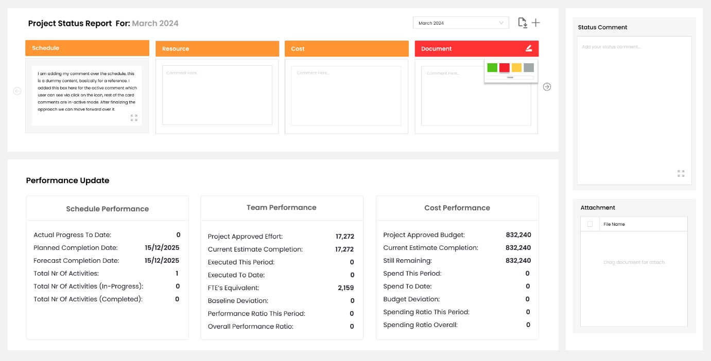

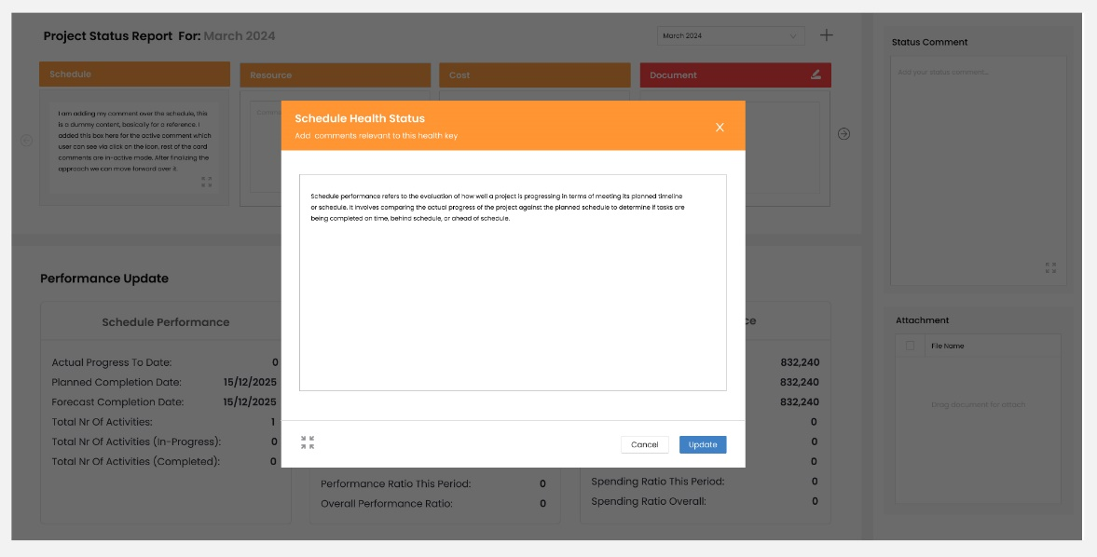

**Status Report - Permission facility for project & portfolio:**

**Creation of "Status Report Permission" Setting:**

* User navigates to the configuration page of the application.
* Setting named "Status Report Permission" is created within the configuration page.
* User clicks on the "Status Report Permission" setting, triggering a popup window to appear.

**Switcher Options for Permission:**

* Within the popup, the user is presented with a switcher interface offering two options:
* Initiate permission for status report in the project module.
* Initiate permission for status report in the portfolio.
* Regardless of the chosen option, the respective managers are granted permission to access the status reports.

**Note:** This setting can go under the general setting to instead of introducing new icon here as per the feasibility for assigning the permission.

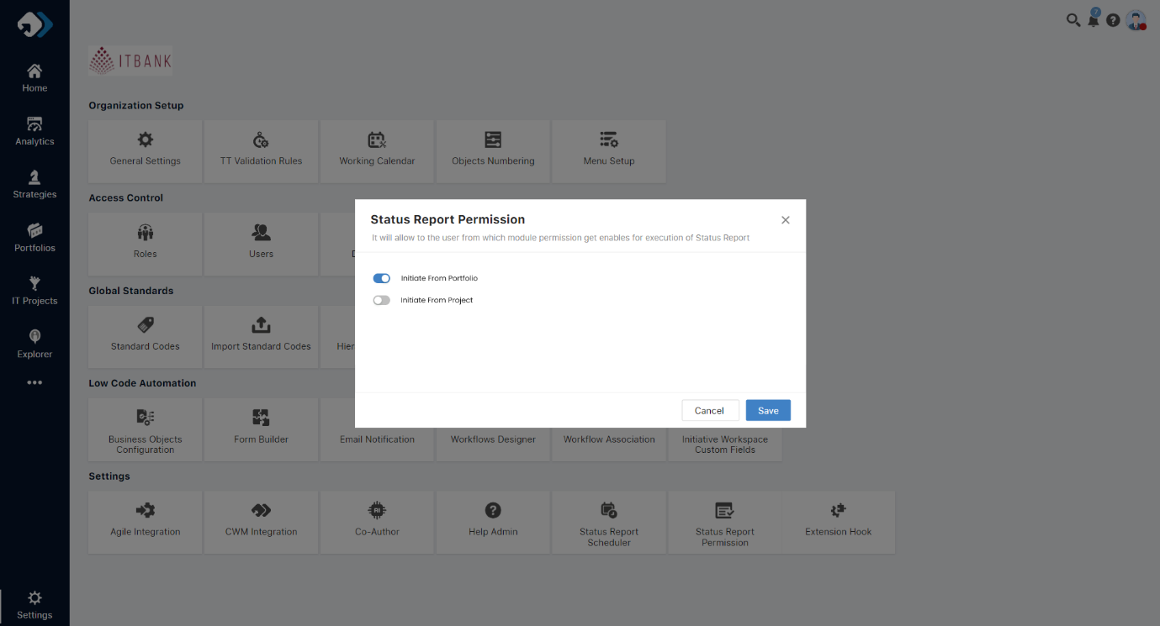

**Permission for Project Module:**

* If the user selects to initiate permission for the project module:
  + The status report functionality will be activated within the project workspace as similar to the current one.
  + Similar to the existing functionality in the POX, a submit icon will be displayed on the page for users to submit status reports.
  + Also, after that email will get send automatically to get notify regarding the report.



**Permission for Portfolio:**

* If the user selects to initiate permission for the portfolio:
  + The status report functionality will be activated within the portfolio view.
  + An email notify icon is added to allow to show that the email requests is submitted against the project within the status update widget on the portfolio.
  + Added the facility for create new status update from the widget over portfolio if the permission allows over the same from the new added setting while selecting the projects, single or multiple.
  + After creating a status report through the creation popup via selected project will get enable and show in a status update register of TeamSpace.
  + Highlight with sober background-colour which gets aligned with the application theme and also make the difference between the updated period

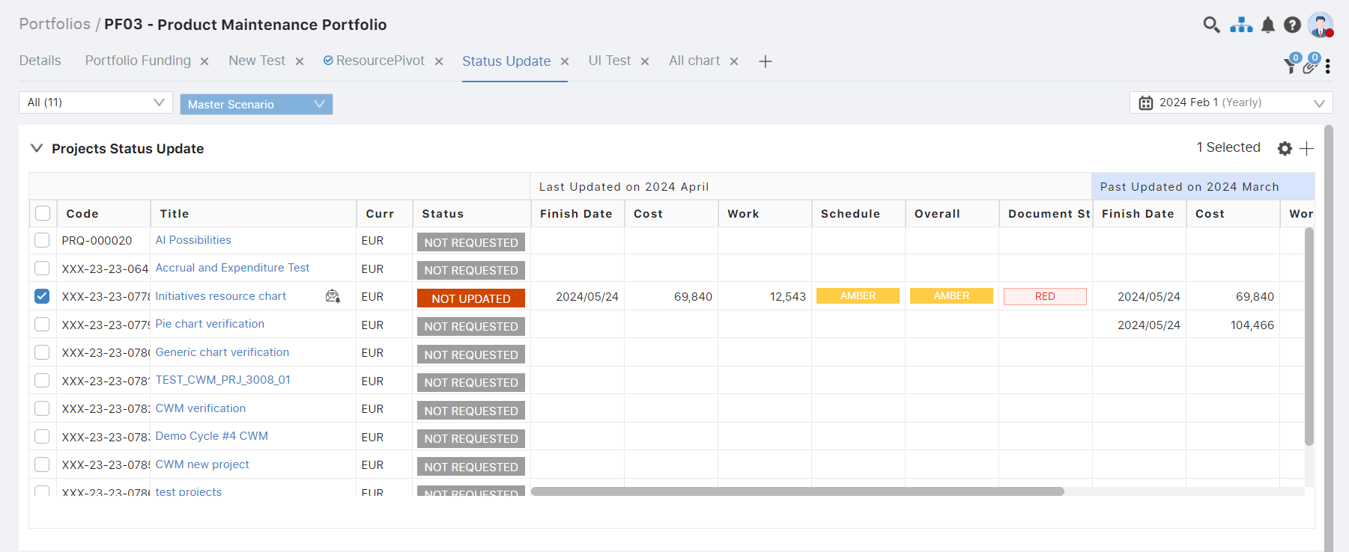

**Create Status from Portfolio:**

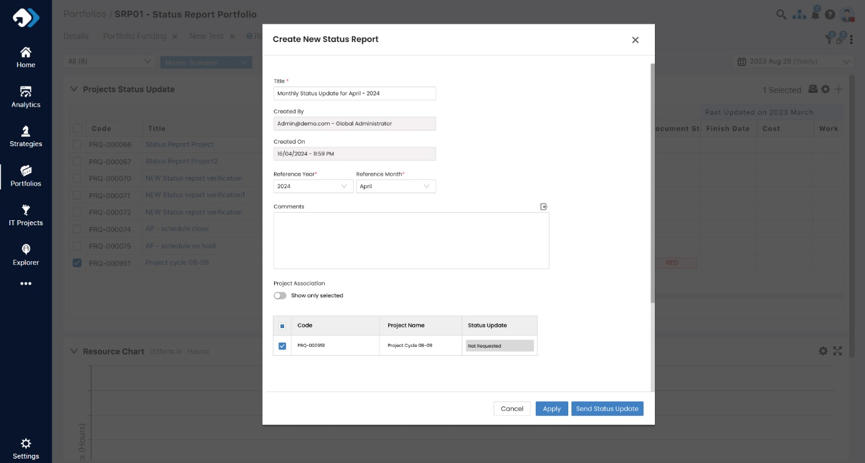

**Highlight the period, added email notify option based on selection:**

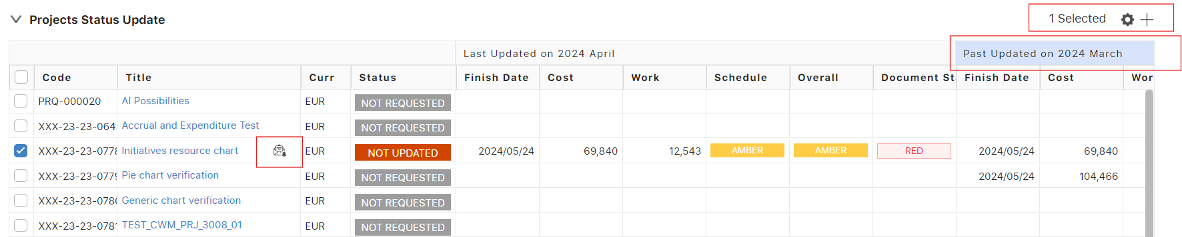

**Status Report on TeamSpace Register:**

Here, we are calling the status report over status update form as similar like project workspace.

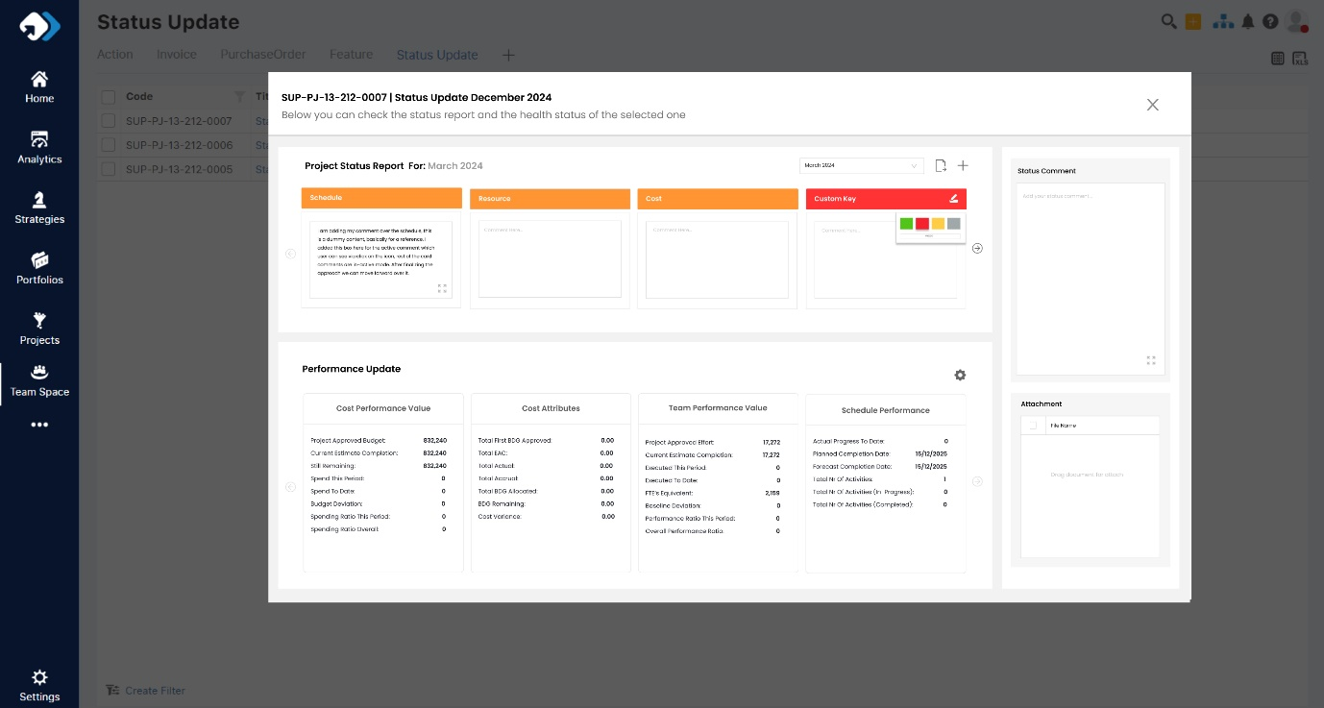

**Note:** Data is dummy, this mock-up is just a reference for status report and health status on popup

**Additional Point Includes:**

Based on our initial discussion regarding the fields and the approach to managing customer visibility, we will incorporate cost performance value alongside calculated attributes data. Additionally, we will ensure that field names align with the current ones based on the data source. For further clarification, please refer to the screenshot below.

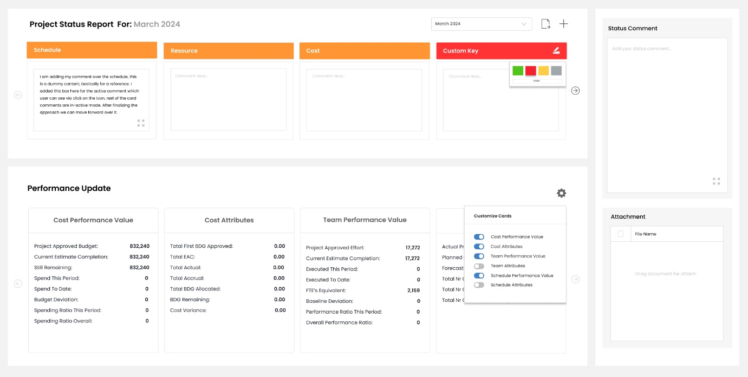

**Figma Link:**

<https://www.figma.com/proto/N6VJzCKvfStZTMwrpgALRB/Status-Report---SPM?type=design&node-id=1-1936&t=F9cKSNO9XguvBczh-0&scaling=scale-down&page-id=0%3A1>

**Label changes over the performance card:**

**Cost Data**

* Total First BDG Approved (Budget)
* Total Budget Estimated Confirmed (EAC)
* Total Actual
* Total BDG Approved
* Total BDG Allocated
* Cost Variance

**Performance Indicator**

* Actual Cost this Period
* Actual Cost to Date
* Budget Deviation
* Spending Ratio this Period
* Spending Ratio to Date
* ETC

